SASF Green Champions Internship
Community Awareness Activity Report

July 20, 2025

Prepared by
<Name of the Student>
<Class of the Student>
<School of the student>

Student Details

Description | Details
Full Name: | <Specify details>
Class/Grade: | <Specify details>
School Name: | <Specify details>
City & State: | <Specify details>
Mobile Number: | <Specify details>
Email ID: | <Specify details>

Awareness Activity Summary

Description | Details
Date(s) of Awareness Activity: | <Specify details>
Location(s): (e.g., society, park, school, neighbourhood) | <Specify details>
Target Audience: (e.g., parents, relatives, neighbours) | <Specify details>
Mode of Awareness: | <Specify details>
One-on-one Conversations | <Y/N>
Group Sessions | <Y/N>
Posters/Pamphlets | <Y/N>
WhatsApp or Social Media | <Y/N>
Other: | <Specify details>

Number of People Reached

Description | Details
Total number of individuals you spoke to or shared the information with: | <Specify details>

Topics Covered

✔ What did you talk about? Mention 3–5 key points you shared
<Topic 1> | <Specify details>
<Topic 2> | <Specify details>
<Topic 3> | <Specify details>
<Topic 4> | <Specify details>
<Topic 5> | <Specify details>

Evidence & Supporting Material
Attach or insert any of the following as evidence:
- Photos of sessions/discussions/posters
- Screenshots of WhatsApp/social media posts
- Names/signatures of people informed (if available)
- Pamphlets/posters you created (optional)

Reflection (Optional but Encouraged)
🗣 What did you learn from this activity? How did people react?
(Max: 500 words)

Declaration

I declare that the information provided above is true and the awareness activity was carried out by me as part of SAS Foundation’s Green Champions Internship 2025.
Signature: _____________________
Date: _________________________
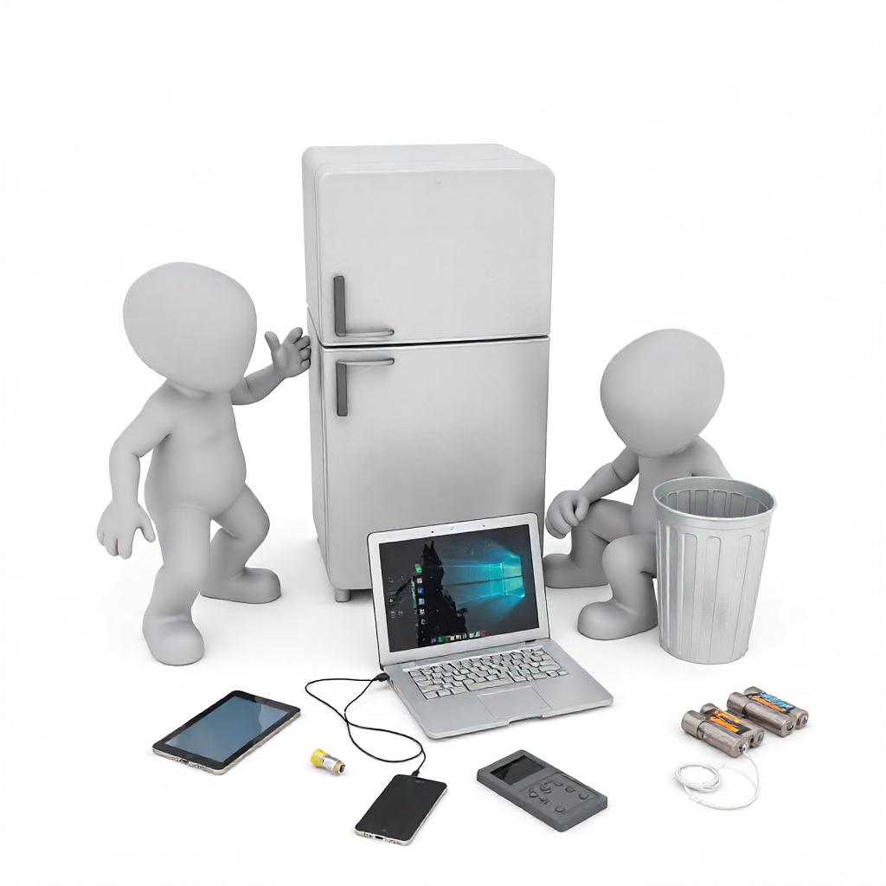

By submitting this report, I acknowledge that the information and media provided may be used, reproduced, and published by SAS Foundation for educational, marketing, reporting, and promotional purposes across various platforms. No personal information will be shared without prior consent.

